ER DIAGRAM
ER Diagram
The ShopEZ ER Diagram represents the entities and relationships involved in the e-commerce platform. It illustrates how users, products, cart, orders, and admin functionalities are interconnected.
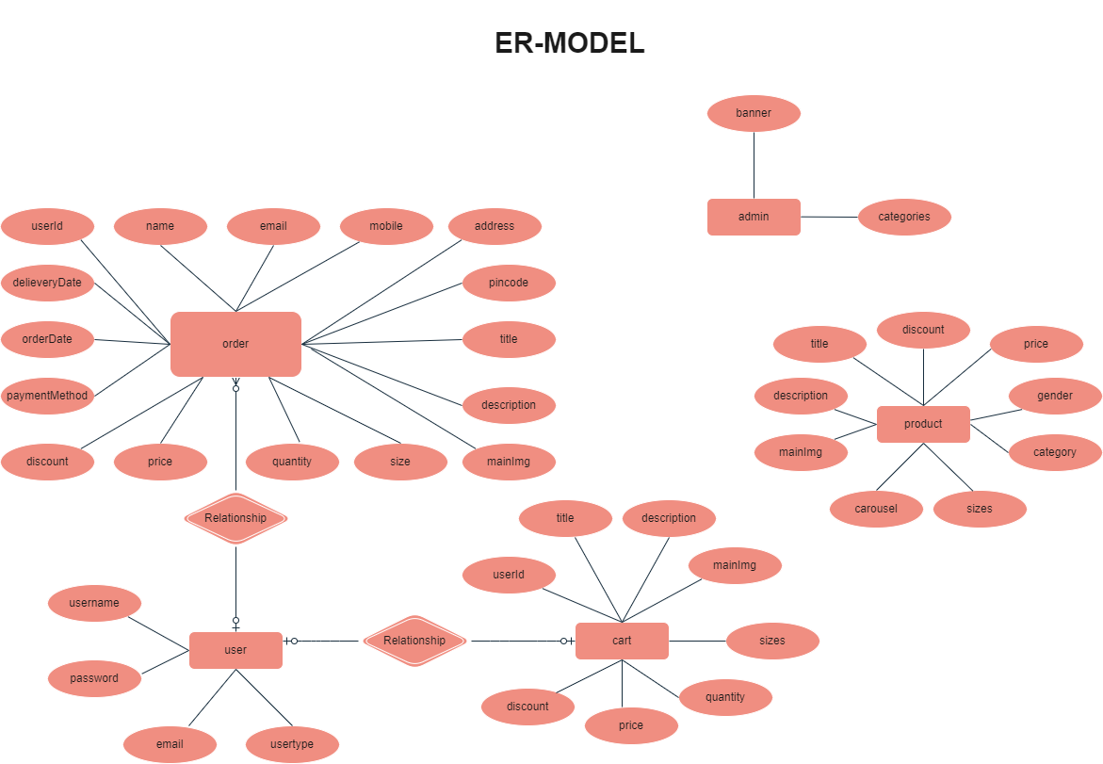
Entities:
User
- Represents registered users of the platform.
- Stores user details such as username, email, and password.
Admin
- Represents administrative information including categories and banner details.
- Responsible for managing products and orders.
Products
- Contains all product information available on the platform.
- Stores product name, description, category, price, and image details.
Cart
- Stores products added to the cart by users.
- Each cart item is associated with a specific user.
Orders
- Stores all orders placed by users.
- Contains product information, quantity, address, payment details, and order status.
Relationships
- One User can have multiple Cart items.
- One User can place multiple Orders.
- Products can appear in multiple Cart records.
- Products can appear in multiple Orders.
- Admin manages Products and Orders.

